**Classwork 2: DML and DQL Statement**

**Name: Ragini Singh**

**Cohort: Jensen Huang**

**Roll No: 150096724023**

**Teacher Name: Sandhya Jamale**

**Date: 21/01/2025**

**Topic: Classwork 2**

# Classwork 2: DML and DQL Statements:

**upload screenshot of all the statements with output:**

**1. Set Up a Database 👍**

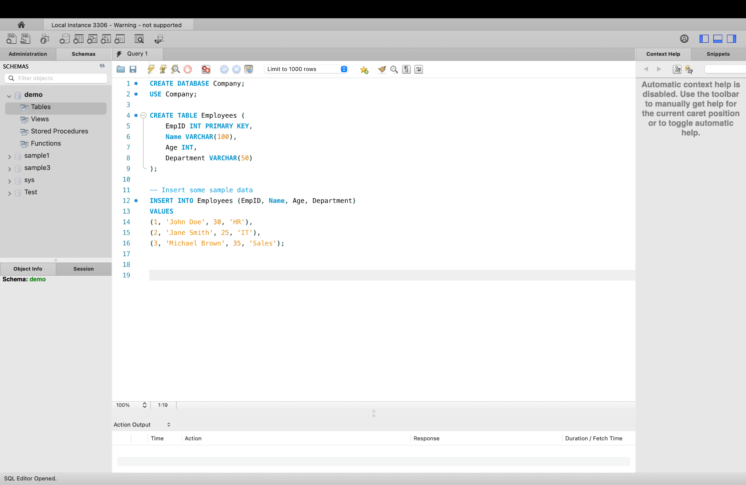

**2. Execute DML and DQL Queries 👍**

#### **DML (Data Manipulation Language) Statements:**

1. **INSERT Statement:**

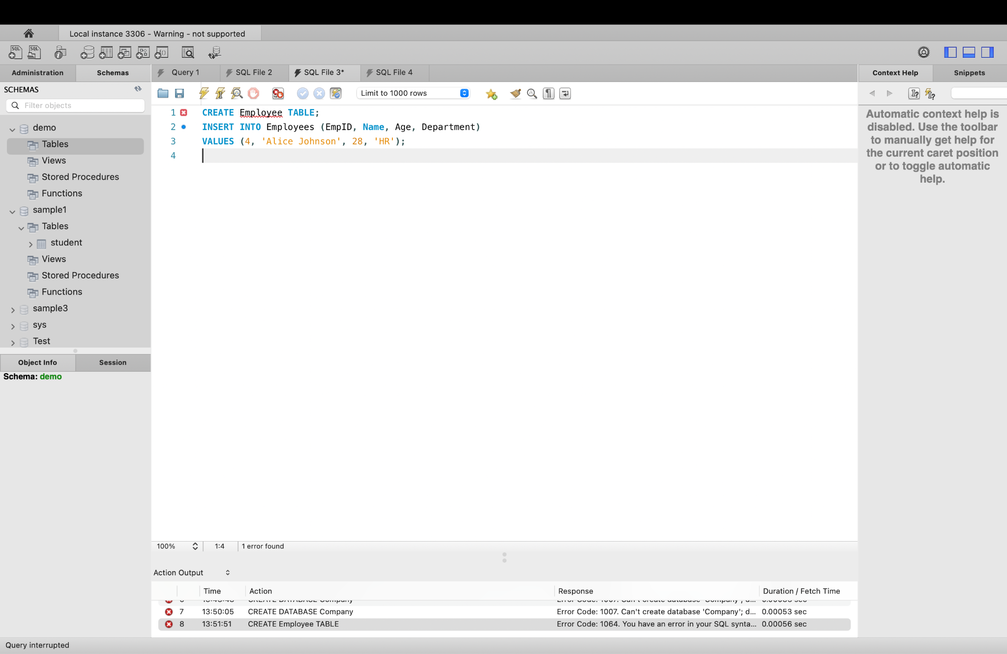

**Output: Inserts a new record into the Employees table.**

**2 : UPDATE Statement:**

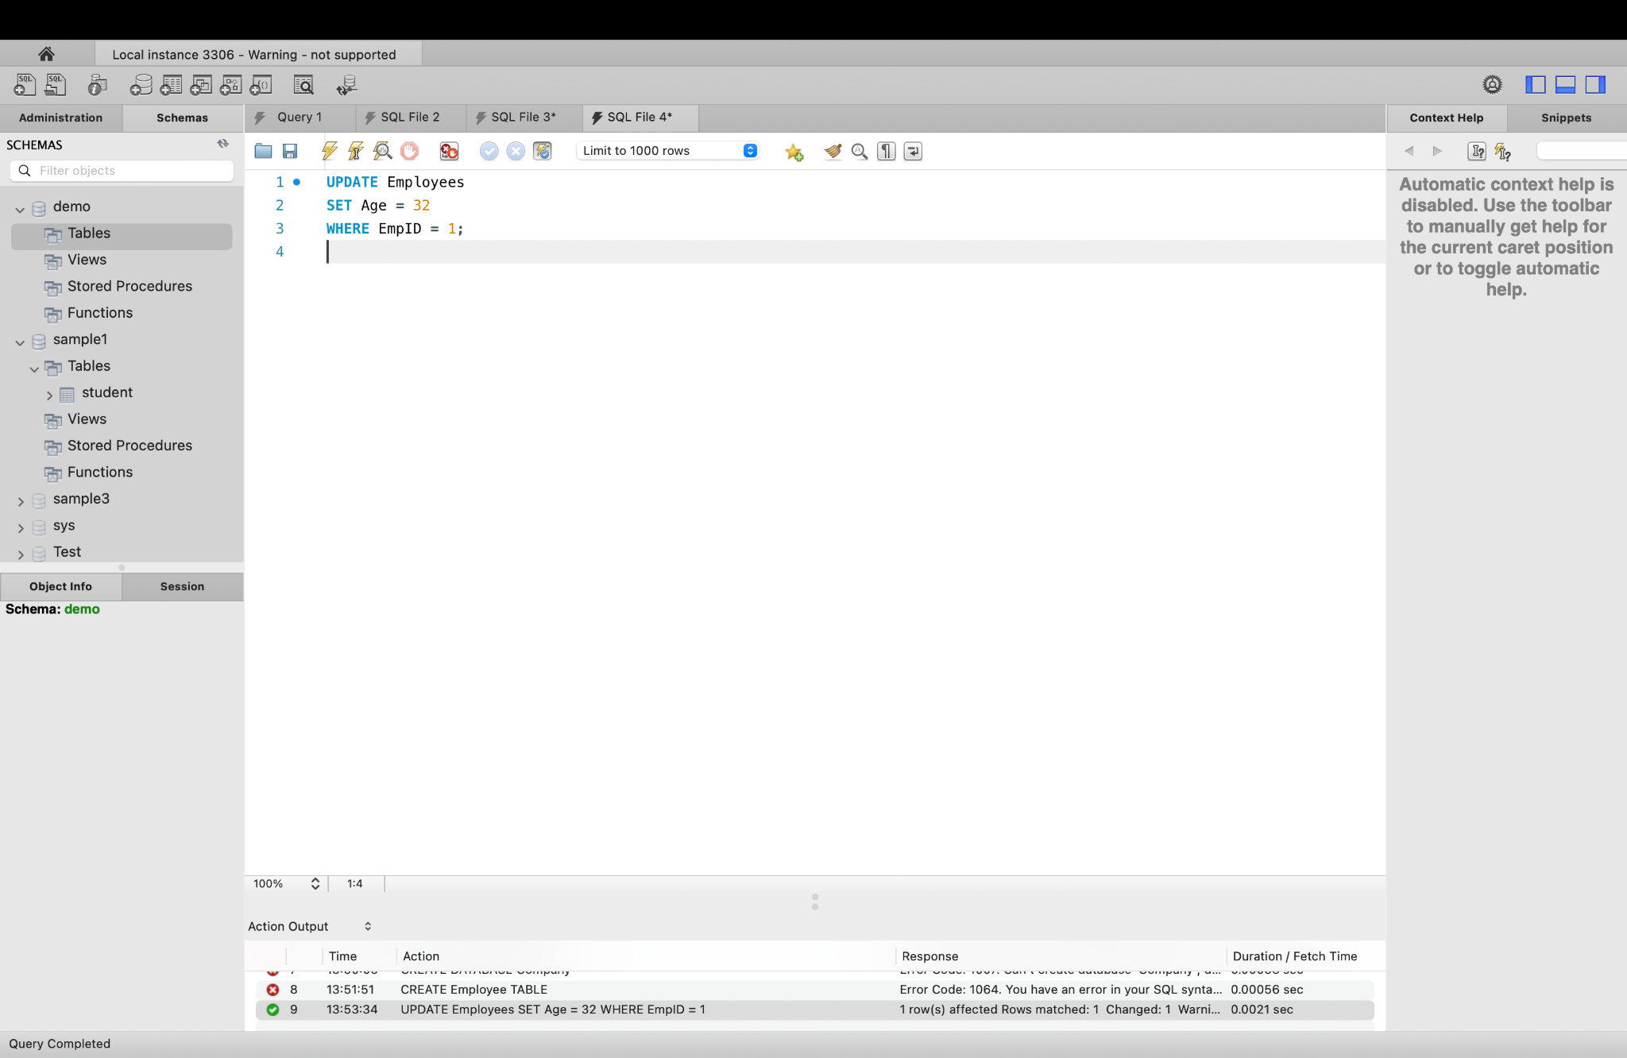

**3 DELETE Statement:**

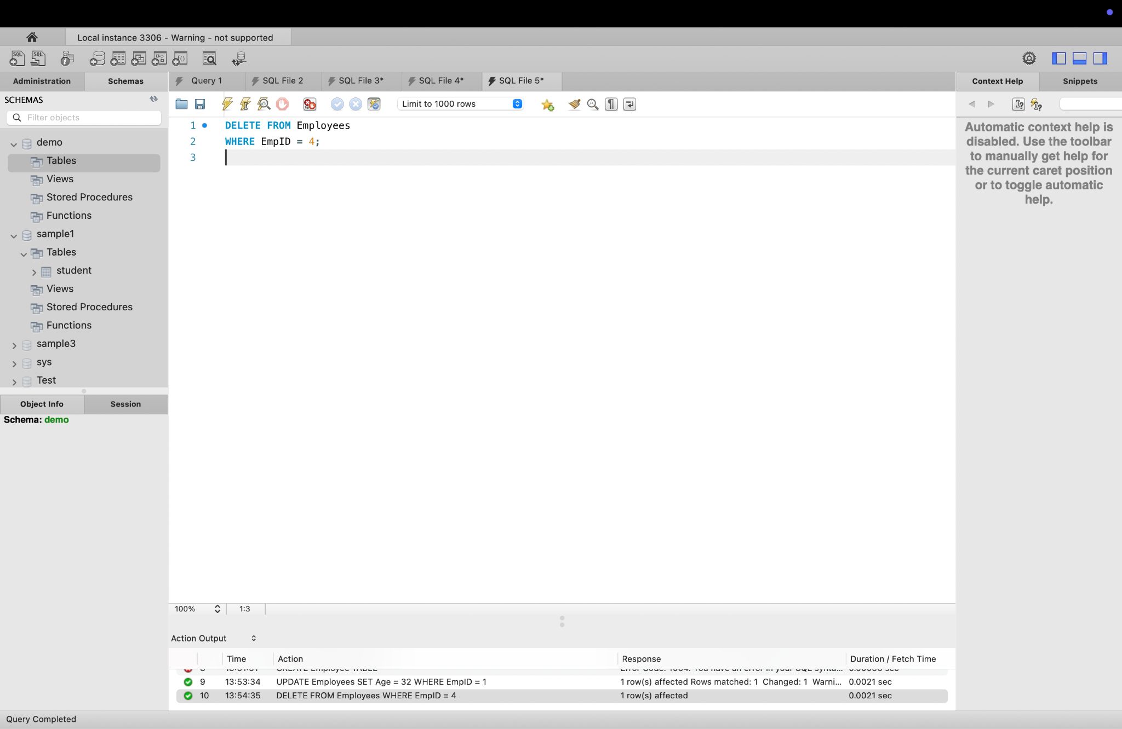

**4 MERGE (Upsert) Statement:**

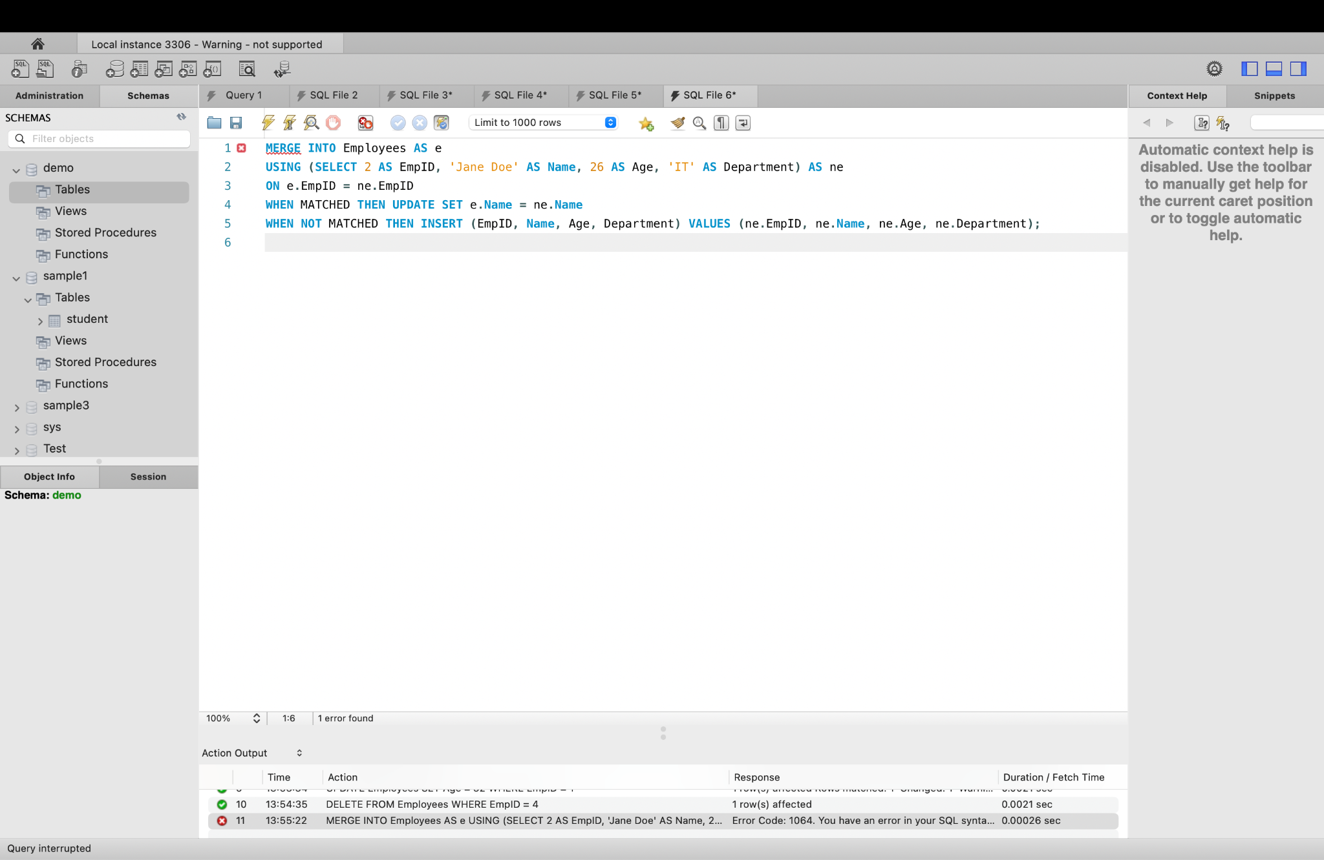

#### **DQL (Data Query Language) Statements:**

1. **SELECT Statement:**

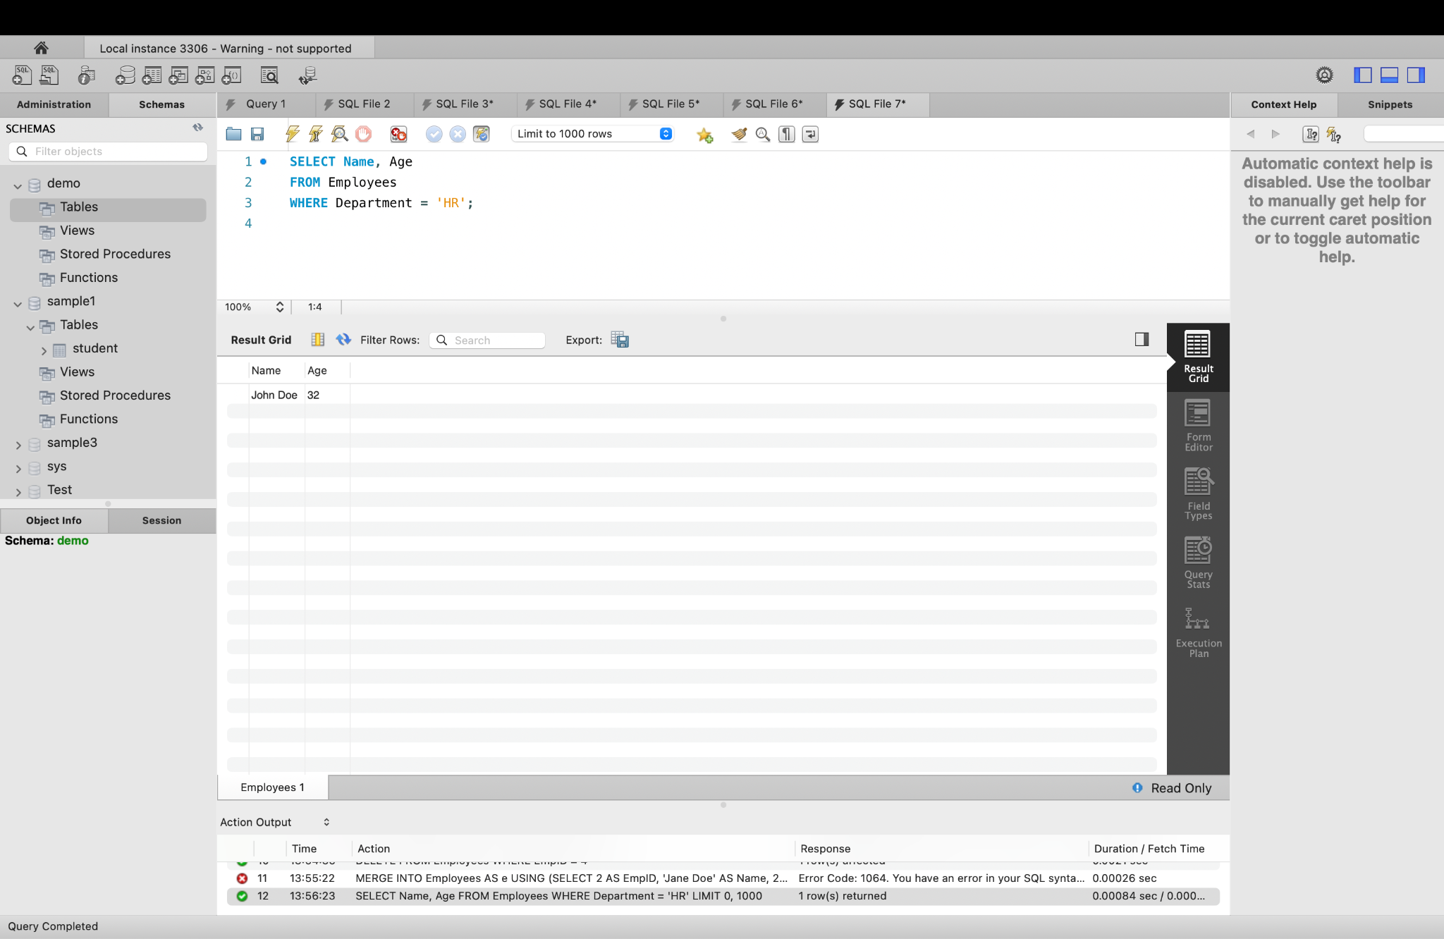

1. **SELECT with JOIN (Assume you have a Departments table):**

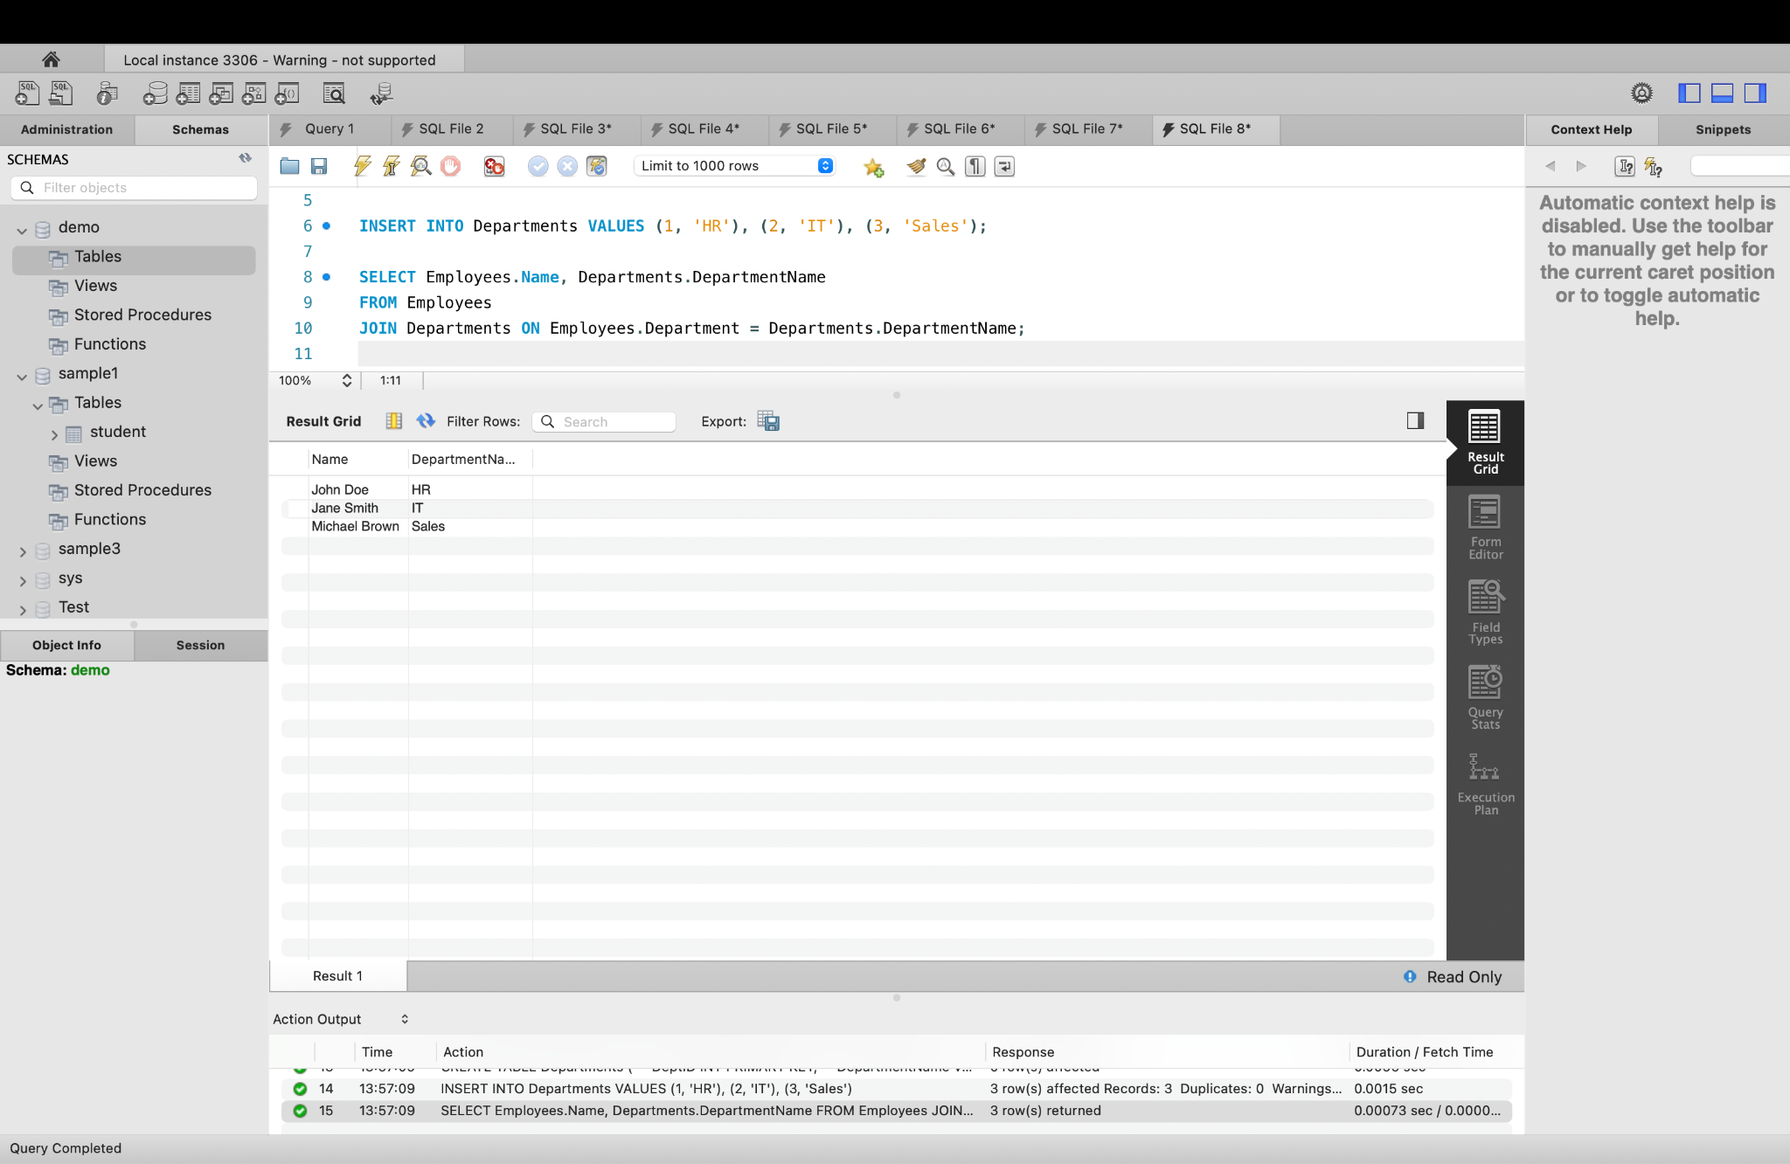

1. **SELECT with GROUP BY:**

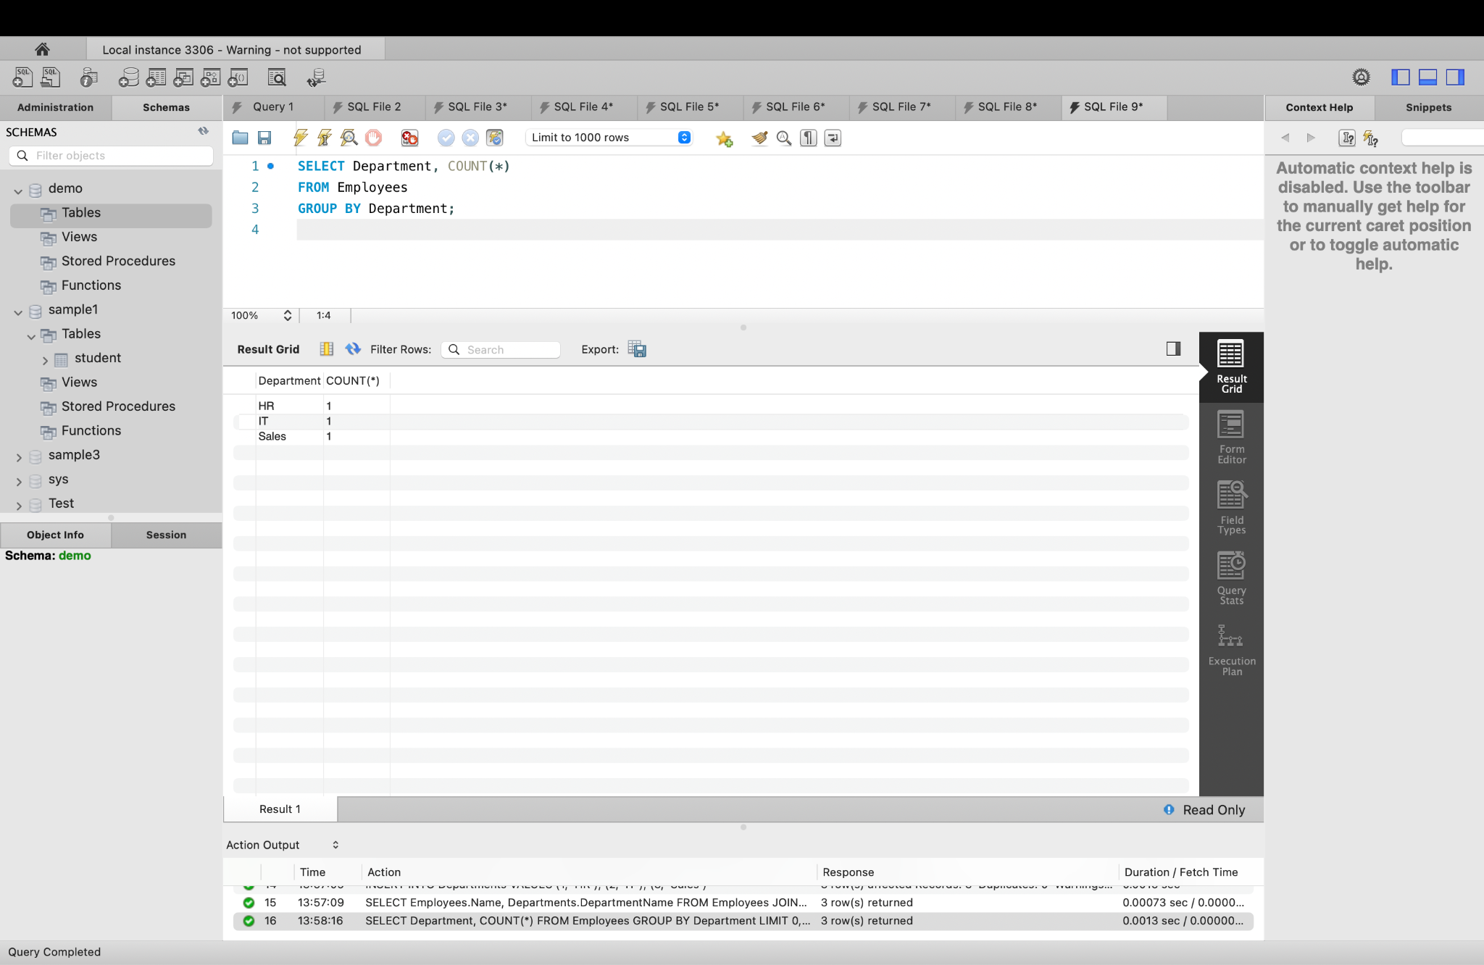

**4 SELECT with HAVING:**

